1. Introduction to Unsupervised Learning
What is Unsupervised Learning?
Unsupervised learning is a type of machine learning where:
- No target labels (y) are provided
- The model tries to discover hidden patterns or structures in the data
📌 Example:
- Grouping customers based on behavior
- Segmenting users without knowing their categories
- Image compression
- Anomaly detection
Key Difference
Supervised | Unsupervised
Labeled data | Unlabeled data
Predict outcomes | Discover structure
Classification, Regression | Clustering, Dimensionality Reduction

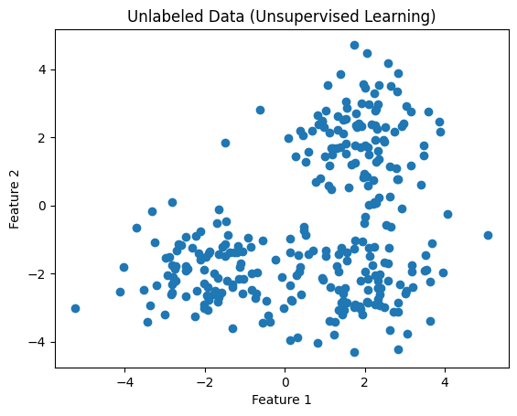
📊 Image 1: Unlabeled Data (What the Model Sees)
- Each point is a data sample
- No labels, no colors
- The model must figure out structure on its own

2. What is Clustering?
Clustering means:
Grouping similar data points together so that:
- Points within a cluster are similar
- Points between clusters are different
Real-life examples:
- Customer segmentation
- News article grouping
- Gene analysis
- Market basket analysis

3. k-Means Clustering (Most Popular Clustering Algorithm)
What is k-Means?
k-Means groups data into k clusters, where:
- Each cluster has a centroid (center)
- Each point belongs to the nearest centroid

🔁 k-Means Algorithm (Step-by-Step)
Step 1: Choose k
Decide how many clusters you want (k = 3, 4, etc.)
Step 2: Initialize Centroids
Randomly place k centroids in the data space
Step 3: Assign Points
Each point is assigned to the nearest centroid
Step 4: Update Centroids
Recalculate centroids as the mean of assigned points
Step 5: Repeat
Repeat Steps 3 & 4 until centroids stop moving

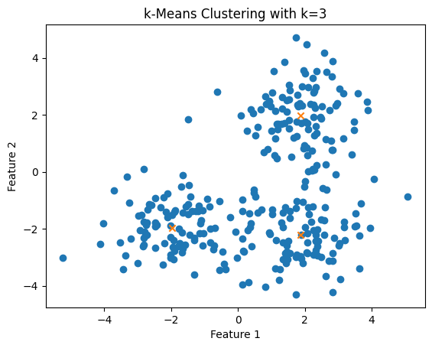
📊 Image 2: k-Means Result (k = 3)
- ❌ Cross marks = centroids
- Clusters are clearly formed
- The algorithm successfully found natural groupings

4. Objective Function of k-Means
k-Means minimizes Within-Cluster Sum of Squares (WCSS)
$$WCSS=\sum_{clusters}{\sum_{points}{(distance to centroid}})^{2}$$
👉 Lower WCSS = tighter, better clusters

5. Random Initialization Trap (Important Problem ⚠️)
What is the problem?
- k-Means starts with random centroids
- Bad initial centroids can lead to:
  - Poor clustering
  - Local minimum
  - Incorrect groups

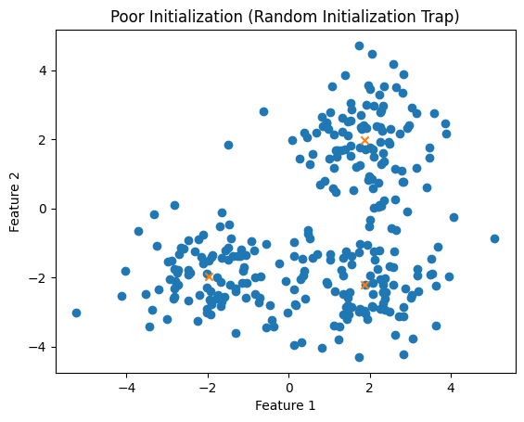
📊 Image 3: Random Initialization Trap
- Centroids start at bad positions
- Algorithm converges early
- Clusters are not optimal
📌 This happens because k-Means:
- Is not guaranteed to find the global optimum
- Depends heavily on starting points

✅ How to Avoid This Trap
- Multiple initializations (n_init)
- k-Means++ initialization (smart centroid placement)
- Run k-Means several times and pick the best result

6. How Do We Choose the Best k? 🤔
→ Elbow Method
Problem:
k is NOT known beforehand
Solution:
Use the Elbow Method

🔍 Elbow Method Explained
Steps:
- Run k-Means for k = 1 to 10
- Compute WCSS for each k
- Plot k vs WCSS
- Look for an “elbow point”

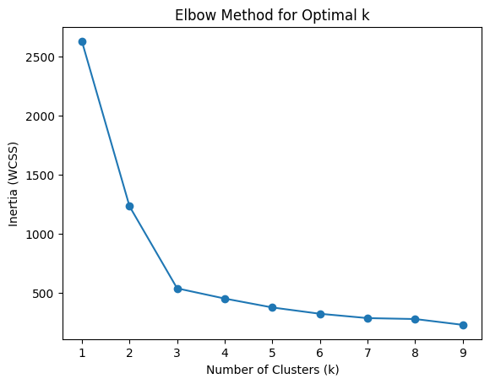
📊 Image 4: Elbow Method Graph
- X-axis → Number of clusters (k)
- Y-axis → WCSS
- Sharp drop initially
- After a point, improvement slows
📌 The elbow point is the optimal k
(In this case, k ≈ 3)

Why is it called “Elbow”?
Because the graph shape looks like a bent elbow 💪

7. Summary (Quick Revision)
Key Takeaways
✔ Unsupervised learning finds hidden patterns
✔ Clustering groups similar data points
✔ k-Means is simple, fast, and popular
✔ Random initialization can cause bad clustering
✔ Use multiple runs or k-Means++
✔ Elbow Method helps choose optimal k

